

PET CARE

**VETERINARY CLINIC MANAGEMENT SYSTEM**

**DATABASE PROJECT**

 **Table of Contents**

1. **CASE STUDY** 3
2. **CONCEPTUAL DESIGNING (ERD)** 4
3. **LOGICAL DESIGNING (SCHEMA)** 5
4. **TABLE** 6
5. **PHYSICAL DESIGNING** 9

**PET CARE**

# **CASE STUDY**

The **Pet Care** is a veterinary clinic that provides full service to its customer. The clinic has become a trusted and care for pets and their owners. The clinic wants to create database to Managing pet and pet owner information, scheduling appointments and handling billing processes.

Each veterinarian has unique Veterinarian id (VID), first name (FNAME), last name (LNAME), phone number and qualifications they possess. Veterinarian can work multiple appointments but an appointment only has one veterinarian assigned. Appointment ID, Appointment Date, Appointment Time and Recommendations are its main information that needs to be stored in the database. Pet owners can make multiple appointments but there must be only one pet owner respective to its appointment. Pet owner has a pet owner id (OID), pet owner full name (FNAME), last name (LNAME), phone number, email and address.

Pet owners can own multiple pets though a pet can only be owned by one pet owner. The clinic wants to store data of its pets under pet id (PETID), pet name (PNAME), breed, gender, date of birth and age. Pet care issues a clinic book for pet once their pet owner makes an appointment. A clinic book has a unique book id (BID) and medical history. Clinic books are issued by receptionists and one receptionist can issue many books while book can only be issued by one receptionist. The entity receptionist has receptionist id (RID), full name, phone number and receptionist email as its attributes. In this pet care clinic, only injured pets are referred to a surgery and other pets are prescribed a prescription based on medical advice. Here the clinic is required to store separately the data of the pets advised to do so. A surgery has a unique surgery id (SID), surgery time and surgery date. The entity prescription has a unique prescription id (PID), medication, dosage and price. An appointment can only have one surgery-vice versa, and can only give one prescription-vice versa.

The vet clinic has products which sells numerous verities of goods related to pets. A product has product id (PRO ID), product name (PRONAME), price and available quantity as attributes. A pet owner can purchase multiple products while a product can be owned by many pet owners.

At last, the clinic wants to store data of its transactions made with customers. For that they need an entity called invoice, (if a person cancels an appointment, they will not receive an invoice. therefore, it is a week entity) an invoice has an invoice id, invoice date, amount and balance. An appointment can only have one invoice-vice versa.

# **CONCEPTUAL DESIGNING (ERD)**

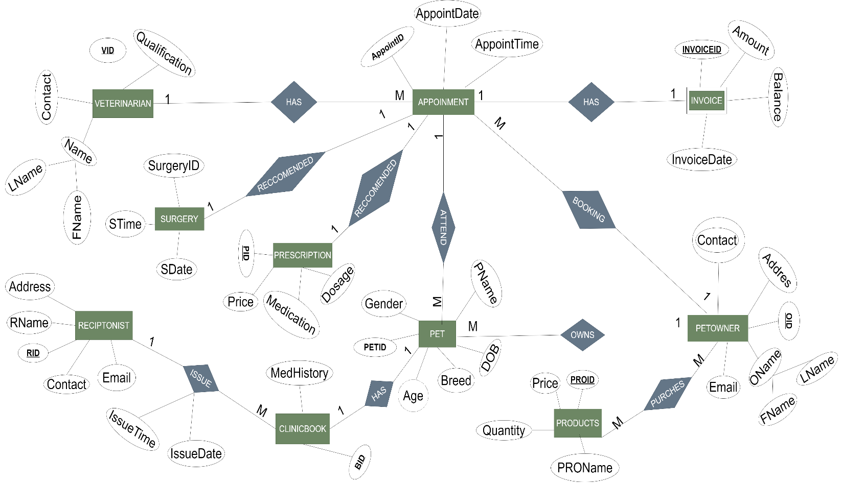

# **LOGICAL DESIGNING (SCHEMA)**

Veterinarian (**VID**, FName, LName, Contact, Qualification)

Appointments (**AppointID,** AppointDate, AppointTime, **VID**, **OID**, **PETID**)

Petowner (**OID,** FName, LName, Contact, Email, Address)

Petowner_Contact (**OID**, Contact)

Pet (**PETID,** PName, DOB, Breed, Gender, Age, **OID**)

Receptionist (**RID,** RName, Contact, Email, Address)

ClinicBook (**BID,** MedHistory, **RID**, **PETID**)

Issue (**RID,** **BID,** IssueDate, IssueTime)

Prescription (**PID,** Dosage, Price, Medication, **AppointID)**

Surgery (**SURGERYID,** SDate, STime, **AppointID**)

Product (**PROID,** PROName, Price, Quantity)

Invoice (**InvoiceID,** InvoiceDate, Amount, Balance)

Petowner_Product (**OID**, **PROID**)

# **TABLE**

1. **Veterinarian Table**

|  |  |
| --- | --- |
| **COLUMN NAME** | **DATA TYPE** |
| **VID (PRIMARY KEY)** | **Varchar (20)** |
| **FName** | **Varchar (50)** |
| **LName** | **Varchar (50)** |
| **Email** | **Varchar (100)** |
| **Phone** | **Varchar (10)** |
| **Qualification** | **Varchar (200)** |

1. **Pet Owner Table**

|  |  |
| --- | --- |
| **COLUMN NAME** | **DATA TYPE** |
| **OID (PRIMARY KEY)** | **Varchar (20)** |
| **FName** | **Varchar (50)** |
| **LName** | **Varchar (50)** |
| **Email** | **Varchar (100)** |
| **Phone** | **Varchar (10)** |
| **Address** | **Varchar (200)** |

1. **Pet Table**

|  |  |
| --- | --- |
| **COLUMN NAME** | **DATA TYPE** |
| **PETID (PRIMARY KEY)** | **Varchar (20)** |
| **PName** | **Varchar (50)** |
| **Breed** | **Varchar (10)** |
| **Gender** | **Varchar (10)** |
| **Age** | **Int** |

1. **Appointment Table**

|  |  |
| --- | --- |
| **COLUMN NAME** | **DATA TYPE** |
| **AppointID (PRIMARY KEY)** | **Varchar (20)** |
| **AppointDate** | **Date** |
| **AppointTime** | **Time** |

1. **Receptionist Table**

|  |  |
| --- | --- |
| **COLUMN NAME** | **DATA TYPE** |
| **RID (PRIMARY KEY)** | **Varchar (20)** |
| **RName** | **Varchar (50)** |
| **Phone** | **Varchar (10)** |
| **Email** | **Varchar (100)** |

1. **Clinic Book Table**

|  |  |
| --- | --- |
| **COLUMN TABLE** | **DATA TYPE** |
| **BID (PRIMARY KEY)** | **Varchar (20)** |
| **Medhistory** | **Varchar (200)** |

1. **Issue Table**

|  |  |
| --- | --- |
| **COLUMN TABLE** | **DATA TYPE** |
| **RID (PRIMARY KEY)** | **Varchar (20)** |
| **BID** | **Varchar (20)** |
| **IssueDate** | **Date** |
| **IssueTime** | **Time** |

1. **Prescription Table**

|  |  |
| --- | --- |
| **COLUMN TABLE** | **DATA TYPE** |
| **PID (PRIMARY KEY)** | **Varchar (20)** |
| **Dosage** | **Varchar (20)** |
| **Medication** | **Varchar (50)** |
| **Price** | **Decimal (10,2)** |

1. **Surgery Table**

|  |  |
| --- | --- |
| **COLUMN TABLE** | **DATA TYPE** |
| **SurgeryID (PRIMARY KEY)** | **Varchar (20)** |
| **SDate** | **Date** |
| **STime** | **Time** |

1. **Product Table**

|  |  |
| --- | --- |
| **COLUMN TABLE** | **DATA TYPE** |
| **PROID (PRIMARY KEY)** | **Varchar (20)** |
| **PROName** | **Varchar (50)** |
| **Price** | **Decimal (10, 2)** |
| **Quantity** | **Int** |

1. **Invoice Table**

|  |  |
| --- | --- |
| **COLUMN TABLE** | **DATA TYPE** |
| **InvoiceID (PRIMARY KEY)** | **Varchar (20)** |
| **InvoiceDate** | **Date** |
| **Amount** | **Decimal (10, 2)** |
| **Balance** | **Decimal (10, 2)** |

# **PHYSICAL DESIGNING**

1. Create a database called PetCare

CREATE DATABASE PetCare;

1. Create table Veterinarian

CREATE TABLE Veterinarian (

VID VARCHAR (20) PRIMARY KEY CHECK (VID LIKE 'V%'),

FName VARCHAR (50) NOT NULL,

LName VARCHAR (50) NOT NULL,

Phone VARCHAR (15) NOT NULL,

Qualification VARCHAR (100)

);

1. Create table PetOwner

CREATE TABLE PetOwner (

OID VARCHAR (20) PRIMARY KEY CHECK (OID LIKE 'O%'),

FName VARCHAR (50) NOT NULL,

LName VARCHAR (50) NOT NULL,

Address VARCHAR 100) NOT NULL,

Phone VARCHAR (20) NOT NULL,

Email VARCHAR (50) NOT NULL

);

1. Create table PetOwner_Contact

CREATE TABLE PetOwner_Contact (

OID VARCHAR (20) foreign key references PetOwner (OID),

Contact VARCHAR (10) NOT NULL,

primary key (OID, Contact)

);

1. Create Table PetOwner

CREATE TABLE PetOwner (

OID VARCHAR (20) PRIMARY KEY CHECK (OID LIKE 'O%'),

FName VARCHAR (50) NOT NULL,

LName VARCHAR (50) NOT NULL,

Address VARCHAR (100) NOT NULL,

Contact VARCHAR (20) NOT NULL,

Email VARCHAR (50) NOT NULL

);

1. Create Table Pet

CREATE TABLE Pet (

PetID VARCHAR (20) PRIMARY KEY CHECK (PetID LIKE 'P%'),

PName VARCHAR (50) NOT NULL,

Breed VARCHAR (50) NOT NULL,

Gender VARCHAR (10) NOT NULL,

Age INT NOT NULL,

DOB DATE NOT NULL,

OID VARCHAR (20) NOT NULL,

FOREIGN KEY (OID) REFERENCES PetOwner (OID)

);

1. Create Table Surgery

CREATE TABLE Surgery (

SurgeryID VARCHAR (20) PRIMARY KEY CHECK (SurgeryID LIKE 'S%'),

SDate DATE NOT NULL,

STime TIME

);

1. Create Table Prescription

CREATE TABLE Prescription (

PID VARCHAR (20) PRIMARY KEY CHECK (PID LIKE 'Pi%'),

Medication VARCHAR (100) NOT NULL,

Dosage VARCHAR (50) NOT NULL,

Price DECIMAL (10, 2) NOT NULL

);

1. Create Table Appointment

CREATE TABLE Appointment (

AppointID VARCHAR (20) PRIMARY KEY CHECK (AppointID like 'A%'),

AppointDate DATE NOT NULL,

AppointTime TIME,

PetID VARCHAR (20) FOREIGN KEY REFERENCES Pet (PetID) NOT NULL,

VID VARCHAR (20) FOREIGN KEY REFERENCES Veterinarian (VID)NOT NULL,

OID VARCHAR (20) FOREIGN KEY REFERENCES PetOwner (OID) NOT NULL,

SurgeryID VARCHAR (20) FOREIGN KEY REFERENCES Surgery (SurgeryID) NOT NULL,

PID VARCHAR (20) FOREIGN KEY REFERENCES Prescription (PID) NOT NULL

);

1. Create Table Receptionist

CREATE TABLE Receptionist (

RID VARCHAR (20) PRIMARY KEY CHECK (RID LIKE 'R%'),

RName VARCHAR (50) NOT NULL,

Contact VARCHAR (15) NOT NULL,

Address VARCHAR (100) NOT NULL,

Email VARCHAR (100) NOT NULL

);

1. Create Table Clinic Book

CREATE TABLE ClinicBook (

BID VARCHAR (20) PRIMARY KEY CHECK (BID LIKE 'B%'),

MedHistory TEXT NOT NULL,

RID VARCHAR (20) NOT NULL,

PetID VARCHAR (20) NOT NULL,

FOREIGN KEY (RID) REFERENCES Receptionist (RID),

FOREIGN KEY (PetID) REFERENCES Pet (PetID)

);

1. Create Table Invoice

CREATE TABLE Invoice (

InvoiceID VARCHAR (20) PRIMARY KEY CHECK (InvoiceID LIKE 'I%'),

Amount DECIMAL (10, 2) NOT NULL,

Balance DECIMAL (10, 2) NOT NULL,

InvoiceDate DATE NOT NULL,

AppointID VARCHAR (20) NOT NULL,

FOREIGN KEY (AppointID) REFERENCES Appointment (AppointID)

);

1. Create Table Products

CREATE TABLE Products (

ProID VARCHAR (20) PRIMARY KEY CHECK (ProID LIKE 'Pr%'),

ProName VARCHAR (50),

Price DECIMAL (10, 2),

Quantity INT

);

1. Create Table Petowner Products

CREATE TABLE PetOwner_Product (

OID VARCHAR (20),

ProID VARCHAR (20),

PRIMARY KEY (OID, ProID),

FOREIGN KEY (OID) REFERENCES PetOwner (OID),

FOREIGN KEY (ProID) REFERENCES Products (ProID)

);

1. Insert Data into Veterinarian Table

INSERT INTO Veterinarian (VID, FName, LName, Phone, Qualification)

VALUES ('V001', 'Kannaggara', 'Gamage', '1234567890', 'DVM'),

('V002', 'Gayan', 'Vidyalankara', '0987654321', 'DVM'),

('V003', 'Sarath', 'Bandula', '1234567890', 'DVM'),

('V004', 'Sandya', 'Wijekoon', '0987654321', 'DVM'),

('V005', 'Shriyani', 'Ranathunga', '0985673211', 'DVM');

1. Insert Data into Petowner Table

INSERT INTO PetOwner (OID, FName, LName, Phone, Email, Address) VALUES

('O001', 'Hasanka', 'Wijesingha', '07745632143', 'hasa@email.com', 'Galle'),

('O002', 'Chamathka', 'Jayodawi', '0743562311', 'chama@email.com', 'Imaduwa'),

('O003', 'Himeshi', 'Kankanamgamage', '8934512654', 'himeshi@email.com', 'Mathara'),

('O004', 'Praween', 'Thilakasiri', '6665553421', 'praween@email.com', 'Galle '),

('O005', 'Amaya', 'Wijethunga', '3452198745', 'amaya.email.com', 'Waligama'),

('O006', 'Sadaruwan', 'Gamage', ' 5673492166 ', 'sadruwn@email.com', 'Imaduwa'),

('O007', 'Abhisheka', 'Vidyalankara', '098674536', 'abhi@email.com', 'Unawatuna'),

('O008', 'Anoma', 'Wimalasiri', '075675382', 'anoma@email.com', 'Galle'),

('O009', 'Deepa', 'Chandani', '0786765342', 'deepa@email.com', 'Kodagoda'),

('O010', 'Vidusha', 'Rajapaksha', '0987654723', 'vidusha@email.com', 'Ampegama'),

('O011', 'Thilini', 'Samarawicrama', '0987876875', 'thilini@email.com', 'Rathgama'),

('O012', 'Asini', 'Sandeepa', '0723456783', 'asini@email.com', 'Hikkaduwa'),

('O013', 'Shashini', 'Subasingha', '0998765643', 'shashi@email.com', 'Waligana'),

('O014', 'Nimsara', 'Ranathunga', '0986745321', 'nimsara@email.com', 'Galle'),

('O015', 'Ashini', 'Divisekara', '09873543523', 'ashi@email.com', 'Akurassa'),

('O016', 'Thanushi', 'Jayawardana', '09533745243', 'thanushi@email.com', 'Mathara'),

('O017', 'Hiruni', 'Wirasinghe', '0978246322', 'hiru@email.com', ' Galle'),

('O018', 'Gihani', 'Sewmini', '0983546767', 'gihani@email.com', 'Kananke '),

('O019', 'Saduni', 'Jayodya', '0754536283', 'saduni@email.com', 'Howpe'),

('O020', 'Rashmi', 'Amodya', '07637474733', 'rashmi@email.com', ' Galle ');

1. Insert Data into Pet Table

INSERT INTO Pet (PetID, PName, Breed, Gender, Age, DOB, OID) VALUES

('P001', 'Buddy', 'Golden Retriever', 'Male', 3, '2020-01-01', 'O001'),

('P002', 'Bella', 'Labrador', 'Female', 2, '2021-05-15', 'O002'),

('P003', 'Jippy', 'Rottweiler', 'Male', 1, '2022-01-01', 'O003'),

('P004', 'Lily', 'Bulldog', 'Female', 1, '2023-05-15', 'O004'),

('P005', 'Sheena', 'German Shepherd', 'Male', 5, '2022-01-03', 'O005'),

('P006', 'Sheeba', 'Labrador', 'Female', 10, '2021-05-07', 'O006'),

('P007', 'Snowi', 'Golden Retriever', 'Male', 3, '2020-01-09', 'O007'),

('P008', 'Peg', 'German Shepherd', 'Female', 2, '2021-05-15', 'O008'),

('P009', 'Pagi', 'Husky', 'Male', 3, '2024-01-01', 'O009'),

('P010', 'Persy', 'Ragdoll', 'Female', 2, '2021-05-15', 'O010'),

('P011', 'Pearl', 'Persian', 'Male', 3, '2021-04-01', 'O011'),

('P012', 'Sasha', 'Ragdoll', 'Female', 2, '2021-05-18', 'O012'),

('P013', 'Robby', 'Persian', 'Male', 3, '2020-01-05', 'O013'),

('P014', 'Roba', 'Persian', 'Female', 2, '2021-05-09', 'O014'),

('P015', 'Rex', 'French Lop', 'Male', 2, '2020-01-20', 'O015'),

('P016', 'Bully', 'American Rabbit', 'Female', 2, '2021-04-15', 'O016'),

('P017', 'Shagi', 'Golden Retriever', 'Male', 3, '2023-03-01', 'O017'),

('P018', 'Scooby', 'Labrador', 'Female', 2, '2021-09-15', 'O018'),

('P019', 'Dolly', 'Golden Retriever', 'Male', 3, '2020-07-01', 'O019'),

('P020', 'Rock', 'Bulldog', 'Female', 2, '2021-06-15', 'O020'),

('P021', 'Shely', 'Golden Retriever', 'Male', 4, '2020-10-01', 'O001'),

('P022', 'Momo', 'Labrador', 'Female', 2, '2021-03-12', 'O002'),

('P023', 'Rangao', 'Golden Retriever', 'Male', 1, '2020-01-30', 'O003'),

('P024', 'Garfield', 'Orange Tabby Persian', 'Female', 1, '2023-05-15', 'O004');

1. Insert Data into Surgery Table

INSERT INTO Surgery (SurgeryID, SDate, STime) VALUES

('S001', '2024-06-10', '09:00:00'),

('S002', '2024-07-15', '10:00:00'),

('S003', '2024-08-05', '11:00:00'),

('S004', '2024-08-20', '14:00:00'),

('S005', '2024-09-10', '15:00:00');

1. Insert Data into Prescription Table

INSERT INTO Prescription (PID, Medication, Dosage, Price) VALUES

('Pi001', 'Antibiotic', '50mg', 12.50),

('Pi002', 'Painkiller', '25mg', 8.75),

('Pi003', 'Vaccine', '1 dose', 20.00),

('Pi004', 'Anti-inflammatory', '100mg', 15.00),

('Pi005', 'Antiseptic', '10ml', 5.00);

1. Insert Data into Appointment Table

INSERT INTO Appointment (AppointID, AppointDate, AppointTime, PetID, VID, OID, SurgeryID, PID) VALUES

('A001', '2024-06-05', '10:00:00', 'P001', 'V001', 'O001', 'S001', 'Pi001'),

('A002', '2024-06-10', '11:00:00', 'P002', 'V002', 'O002', 'S002', 'Pi002'),

('A003', '2024-06-20', '01:00:00', 'P003', 'V003', 'O003', 'S003', 'Pi003'),

('A004', '2024-06-21', '04:00:00', 'P004', 'V004', 'O004', 'S004', 'Pi004'),

('A005', '2024-06-25', '06:00:00', 'P005', 'V005', 'O005', 'S005', 'Pi005'),

('A006', '2024-07-05', '09:00:00', 'P006', 'V001', 'O006', 'S001', 'Pi001'),

('A007', '2024-07-09', '11:00:00', 'P007', 'V002', 'O007', 'S002', 'Pi002'),

('A008', '2024-07-10', '02:00:00', 'P008', 'V003', 'O008', 'S003', 'Pi003'),

('A009', '2024-07-15', '03:00:00', 'P009', 'V004', 'O009', 'S004', 'Pi004'),

('A010', '2024-07-16', '05:00:00', 'P010', 'V005', 'O010', 'S005', 'Pi005'),

('A011', '2024-07-17', '07:00:00', 'P011', 'V001', 'O011', 'S001', 'Pi001'),

('A012', '2024-07-18', '08:00:00', 'P012', 'V002', 'O012', 'S002', 'Pi002'),

('A013', '2024-07-19', '12:00:00', 'P013', 'V003', 'O013', 'S003', 'Pi003'),

('A014', '2024-07-20', '09:00:00', 'P014', 'V004', 'O014', 'S004', 'Pi004'),

('A015', '2024-07-21', '08:00:00', 'P015', 'V005', 'O015', 'S005', 'Pi005'),

('A016', '2024-07-25', '12:00:00', 'P016', 'V001', 'O016', 'S001', 'Pi001'),

('A017', '2024-08-10', '08:00:00', 'P017', 'V002', 'O017', 'S002', 'Pi002'),

('A018', '2024-08-12', '09:00:00', 'P018', 'V003', 'O018', 'S003', 'Pi003'),

('A019', '2024-08-15', '12:00:00', 'P019', 'V004', 'O019', 'S004', 'Pi004'),

('A020', '2024-08-20', '10:00:00', 'P020', 'V005', 'O020', 'S005', 'Pi005')

1. Insert Data into Receptionist Table

INSERT INTO Receptionist (RID, RName, Contact, Email, Address) VALUES

('R001', 'Amal', '0987253623',' amal@email.com','Galle'),

('R002', 'Himali', '0985643789', 'himali@email.com','Mathara'),

('R003', 'Chandani', '0983452555', 'chandani@email.com','Imaduwa'),

('R004', 'Anusha', '0988765234', 'anusha@email.com','Akurassa'),

('R005', 'Vindya', '0989976123', 'vindya@email.com','Hambanthota'),

('R006', 'Rani', '0988934123', 'rani@email.com','Baddegama'),

('R007', 'Shehani', '0987745900', 'shehani@email.com','Hikkaduwa'),

('R008', 'Ashen', '0983423567', 'ashen@email.com','Ambalangoda'),

('R009', 'Saman', '0988976300', 'saman@email.com','Aluthgama'),

('R010', 'Tharidu', '0983421444', 'tharidu@email.com','Galle');

1. Insert Data into Clinic Book Table

INSERT INTO ClinicBook (BID, MedHistory, RID, PetID) VALUES

('B001', 'History1', 'R001', 'P001'),

('B002', 'History2', 'R002', 'P002'),

('B003', 'History3', 'R003', 'P003'),

('B004', 'History4', 'R004', 'P004'),

('B005', 'History5', 'R005', 'P005');

1. Insert Data into Products

INSERT INTO Products (ProID, ProName, Price, Quantity) VALUES

('Pr001', 'Dog Food', 20.00, 50),

('Pr002', 'Cat Food', 15.00, 40),

('Pr003', 'Bird Seed', 5.00, 100),

('Pr004', 'Fish Food', 8.00, 70),

('Pr005', 'Rabbit Food', 12.00, 60)

1. Insert Data into Invoice

INSERT INTO Invoice (InvoiceID, Amount, Balance, InvoiceDate, AppointID) VALUES

('I001', 100.00, 50.00, '2024-06-06', 'A001'),

('I002', 200.00, 150.00, '2024-06-11', 'A002'),

('I003', 150.00, 75.00, '2024-06-21', 'A003'),

('I004', 250.00, 200.00, '2024-06-22', 'A004'),

('I005', 300.00, 100.00, '2024-06-26', 'A005');

1. Selecting All from Pet Owner Table

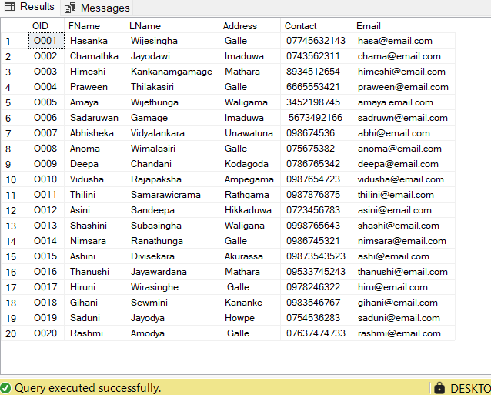SELECT * FROM PetOwner;

1. Selecting All from Pet Table

SELECT * FROM Pet;

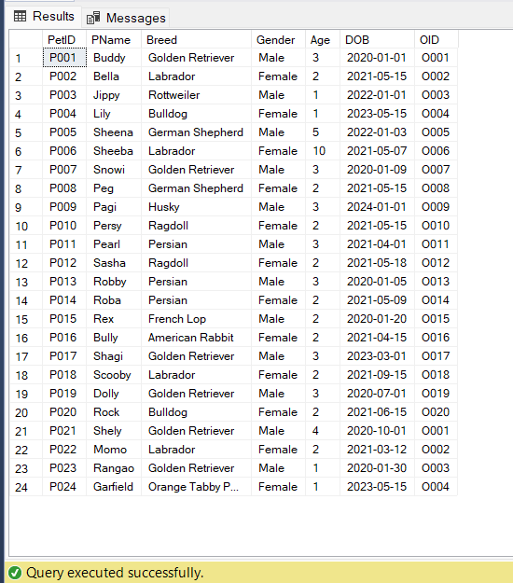

1. Joining Table (INNER JOIN)

SELECT a. AppointID, a. AppointDate, a. AppointTime, p. PName AS PetName, v. FName AS VetFirstName

FROM Appointment a

INNER JOIN Pet p ON a. PetID = p. PetID

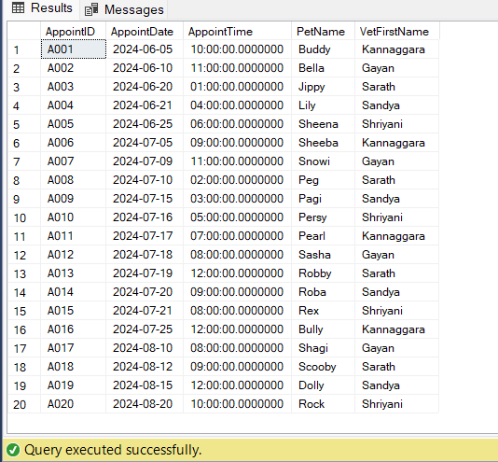INNER JOIN Veterinarian v ON a.VID = v.VID;

1. Joining Table with where clause

SELECT Appointment. AppointID, PetOwner.OID, PetOwner. LName as PetOwner_Name, Appointment.VID

FROM Appointment inner join PetOwner on Appointment.OID=PetOwner.OID

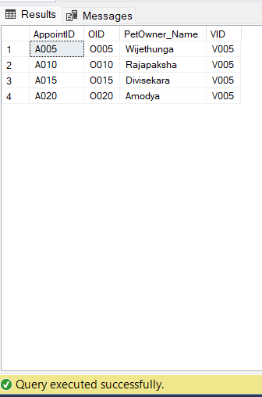WHERE Appointment.VID = 'V005'

1. Joining Table with Group by and Having By

SELECT o.OID, o. FName, o. LName, SUM (I. Amount) AS TotalSpent

FROM PetOwner o

JOIN Appointment a ON o.OID = a.OID

JOIN Invoice i ON a. AppointID = i. AppointID

GROUP BY o.OID, o. FName, o. LName

HAVING SUM (I. Amount) > 150;

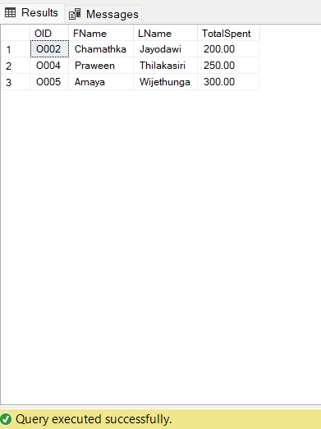

1. Order By

SELECT * FROM Pet

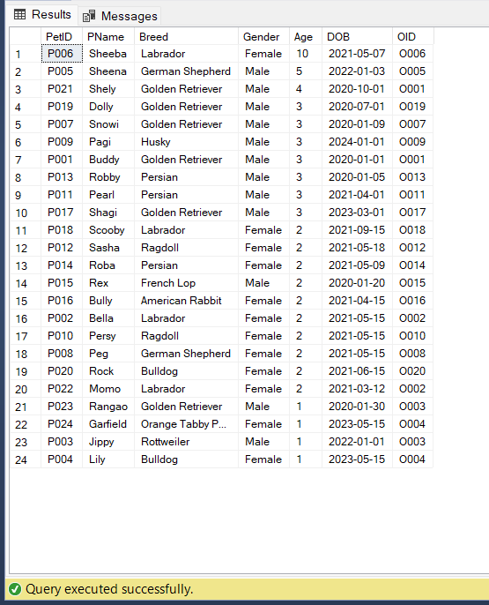ORDER BY Age DESC;

1. Creating SUB QUERIES

SELECT

*

FROM

Prescription

WHERE

Price = (

SELECT

MAX(Price)

FROM

Prescription

);

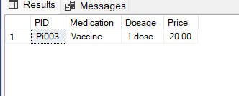

1. Creating VIEWS

CREATE VIEW VR_Attendance AS

SELECT

VID,

LName

FROM

Veterinarian;

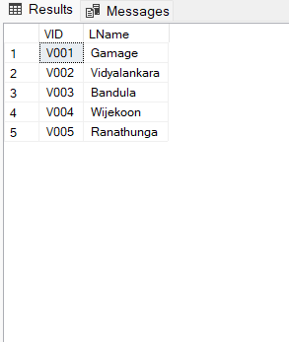

* GROUP MEMBERS: V.S.A (GADSE233F – 008)

K.G.C Jayodavi (GADSE233F – 009)